There can be multiple customers, who can place multiple orders on the site. Now a sales person can handle these orders will distribute into multiple sales persons (One order will be assign to one salesperson only). So a sales person can have multiple orders of multiple customers
- Create Database
create database sales;

- Design Schema

- Create tables
create table salesman (
s_id int PRIMARY KEY,
s_name varchar(30)
);

create table customer(
c_id int PRIMARY KEY,
c_name varchar(30),
address varchar(50),
salesman_id int,
FOREIGN KEY (salesman_id) REFERENCES salesman(s_id)
);

create table orders(
o_id int PRIMARY KEY,
amount int,
c_id int,
s_id int,
FOREIGN KEY (c_id) REFERENCES customer(c_id),
FOREIGN KEY (s_id) REFERENCES salesman(s_id)
);

- Insert sample data
mysql> insert into salesman(s_id,s_name) values ('1001','Rocket singh');
Query OK, 1 row affected (0.07 sec)

mysql> insert into salesman(s_id,s_name) values ('2001','Maqbool Khan');
Query OK, 1 row affected (0.04 sec)

mysql> insert into salesman(s_id,s_name) values ('3001','Anthony');
Query OK, 1 row affected (0.06 sec)
mysql> insert into customer(c_id,c_name,address,salesman_id) values (1,'Mukesh','mumbai','1001');
Query OK, 1 row affected (0.05 sec)

mysql> insert into customer(c_id,c_name,address,salesman_id) values (2,'Rahul','Delhi','1001');
Query OK, 1 row affected (0.04 sec)

mysql> insert into customer(c_id,c_name,address,salesman_id) values (3,'Deepak','Noida','2001');
Query OK, 1 row affected (0.06 sec)

mysql> insert into customer(c_id,c_name,address,salesman_id) values (4,'sahil','Noida','3001');
Query OK, 1 row affected (0.06 sec)

mysql> insert into orders(o_id,amount,c_id,s_id) values (3123,3000,1,2001);
Query OK, 1 row affected (0.04 sec)

mysql> insert into orders(o_id,amount,c_id,s_id) values (2333,1000,3,2001);
Query OK, 1 row affected (0.05 sec)

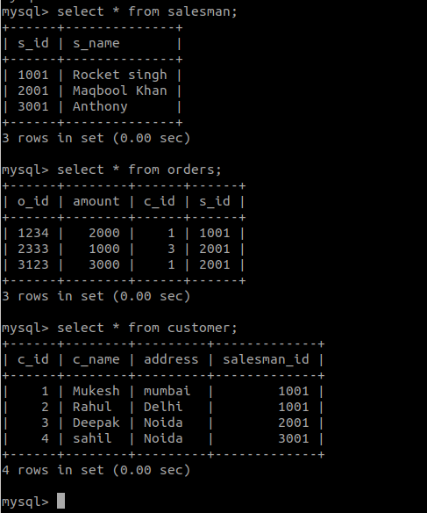
- Find the sales person have multiple orders.
SELECT s.s_name, s.s_id, Count(o.o_id) AS TotalOrders FROM orders o salesman s Where s.s_id = o.s_id GROUP BY s.s_id Order BY Count(o.o_id) DESC limit 1;

- Find the all sales person details along with order details
mysql> SELECT s.* ,o.o_id, o.amount FROM salesman s JOIN orders o ON s.s_id = o.s_id;

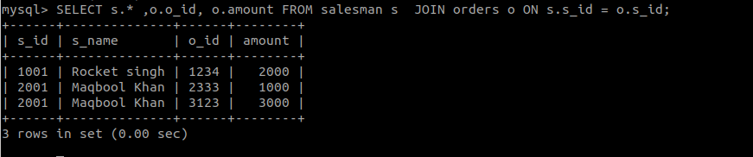

- Create index
Create index idx_order on orders(o_id);
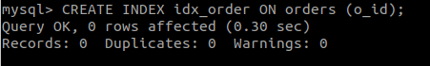
- How to show index on a table
Show index from orders;
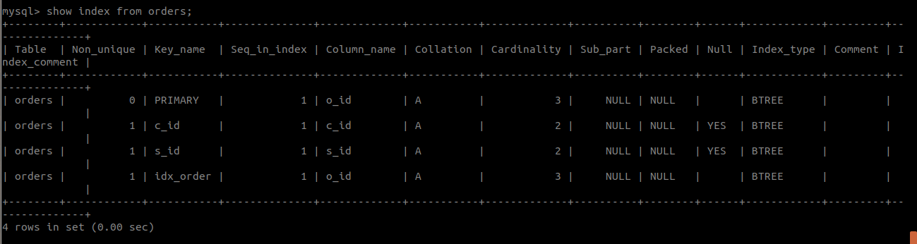

- Find the order number, sale person name, along with the customer to whom that order belongs to
Select o.o_id , s.s_name, c.c_name from orders o , salesman s, customer c where s.s_id = o.s_id AND c.c_id = o.c_id;
